# Steps

[Next](#Step2" \o "Next)

**Step 1: (‎29-‎02-‎2024 15:14:20)** User left click on "Opera Browser - 1 running window (button)"

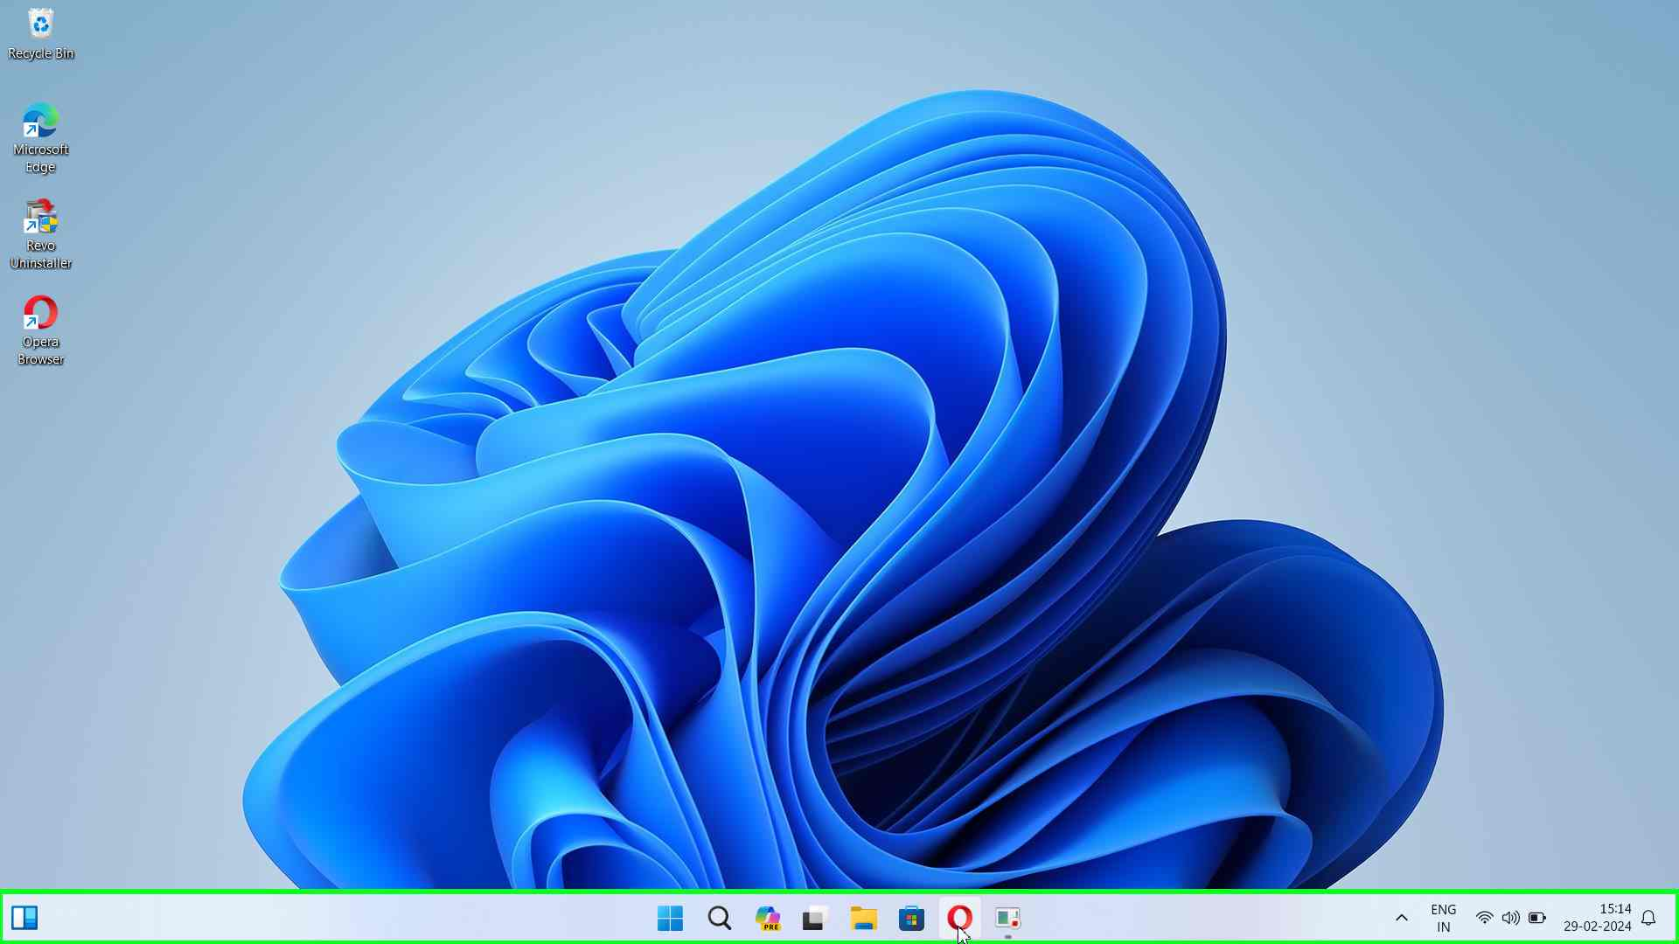Step 1 screenshot.

[Previous](#Step1" \o "Previous) [Next](#Step3" \o "Next)

**Step 2: (‎29-‎02-‎2024 15:14:23)** User keyboard input on "Speed Dial - Opera (pane)" in "Speed Dial - Opera" [... Enter]

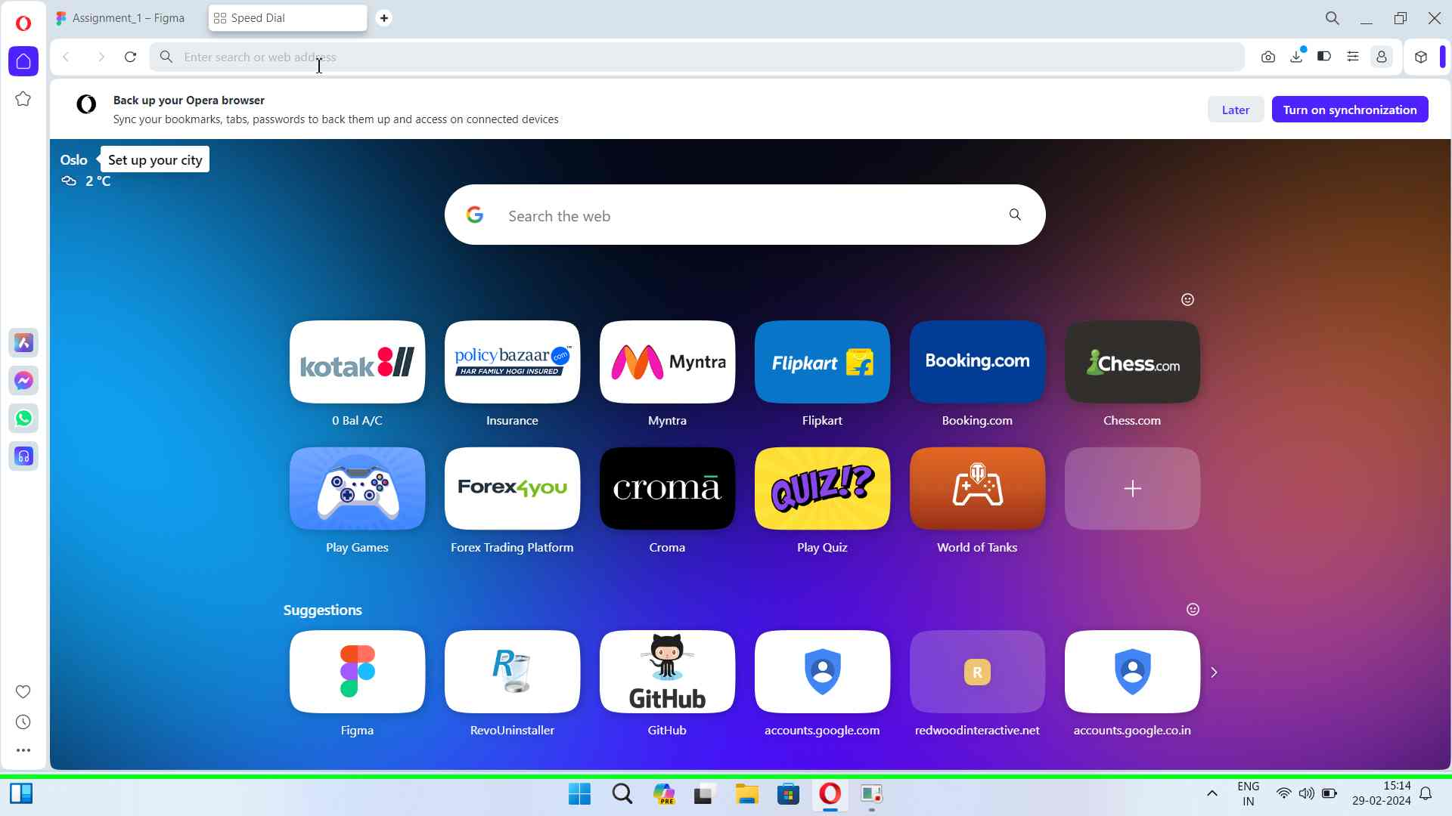Step 2 screenshot.

[Previous](#Step2" \o "Previous) [Next](#Step4" \o "Next)

**Step 3: (‎29-‎02-‎2024 15:14:28)** User left click on "github - Google Search (document)" in "github - Google Search - Opera"

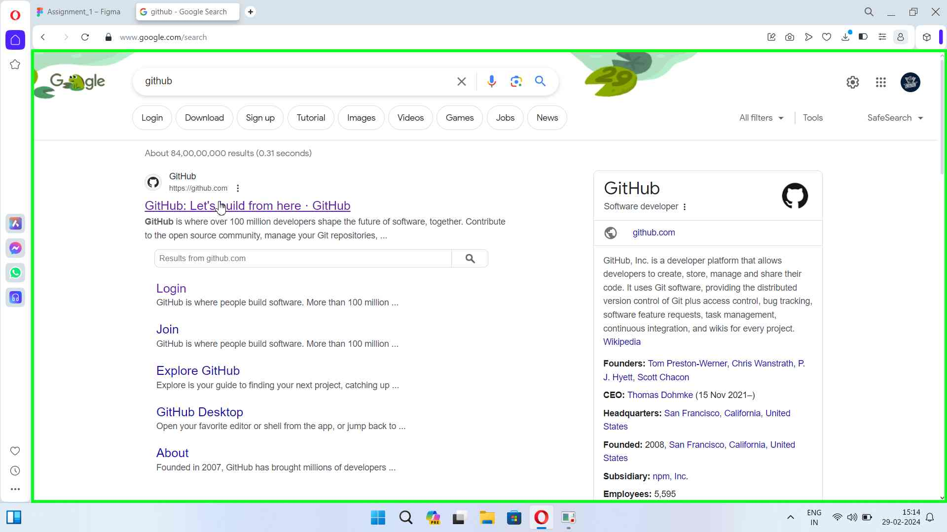Step 3 screenshot.

[Previous](#Step3" \o "Previous) [Next](#Step5" \o "Next)

**Step 4: (‎29-‎02-‎2024 15:14:32)** User left click on "Repository name (edit)" in "GitHub - Opera"

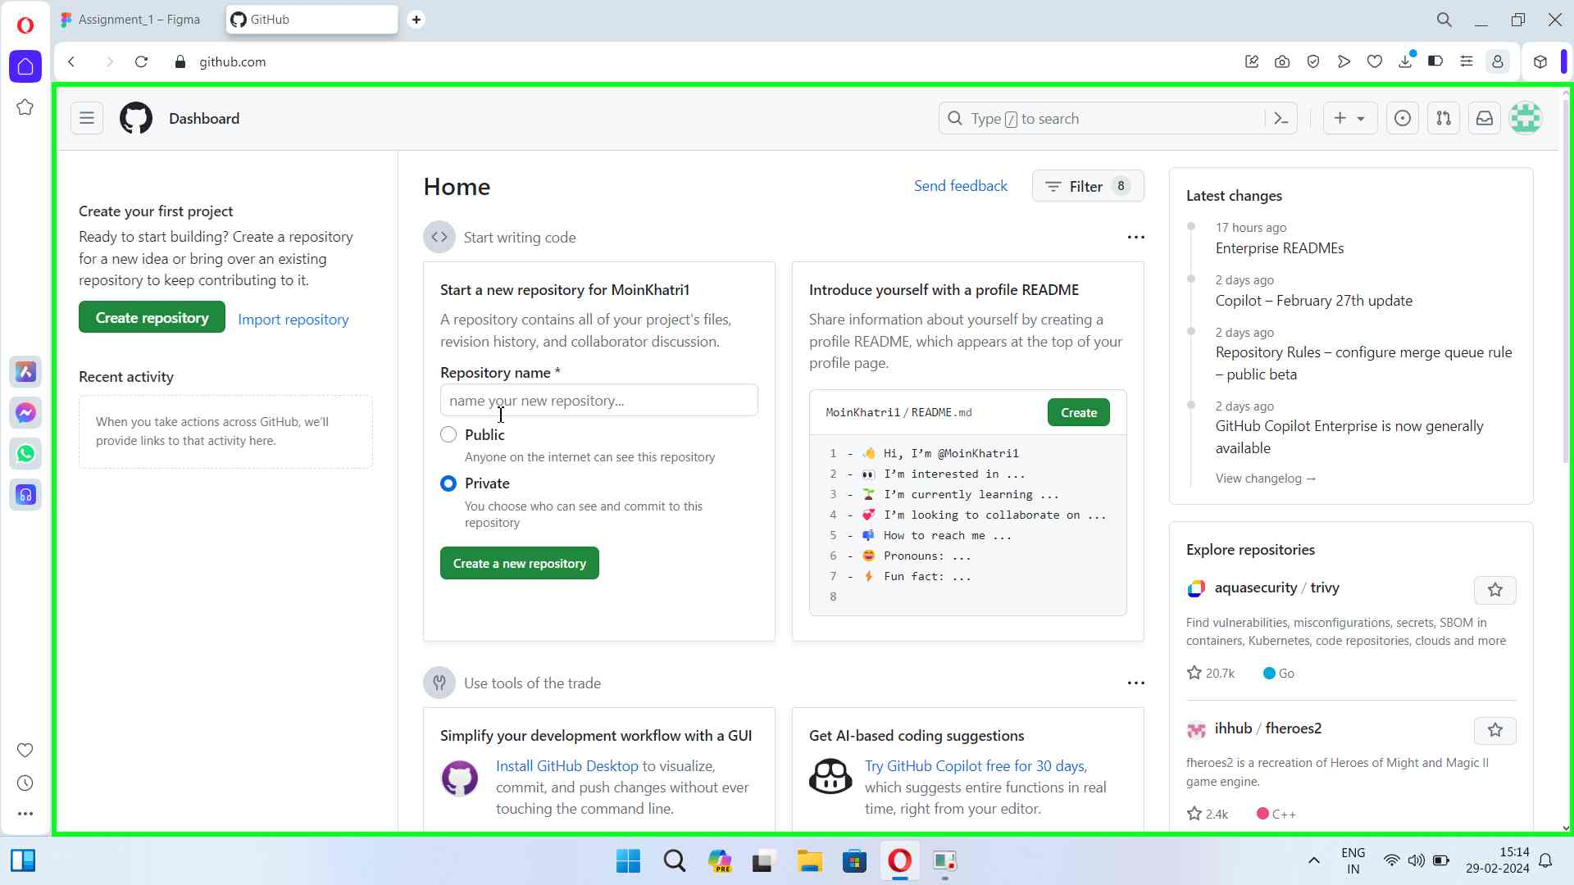Step 4 screenshot.

[Previous](#Step4" \o "Previous) [Next](#Step6" \o "Next)

**Step 5: (‎29-‎02-‎2024 15:14:34)** User keyboard input on "GitHub - Opera (pane)" in "GitHub - Opera" [...]

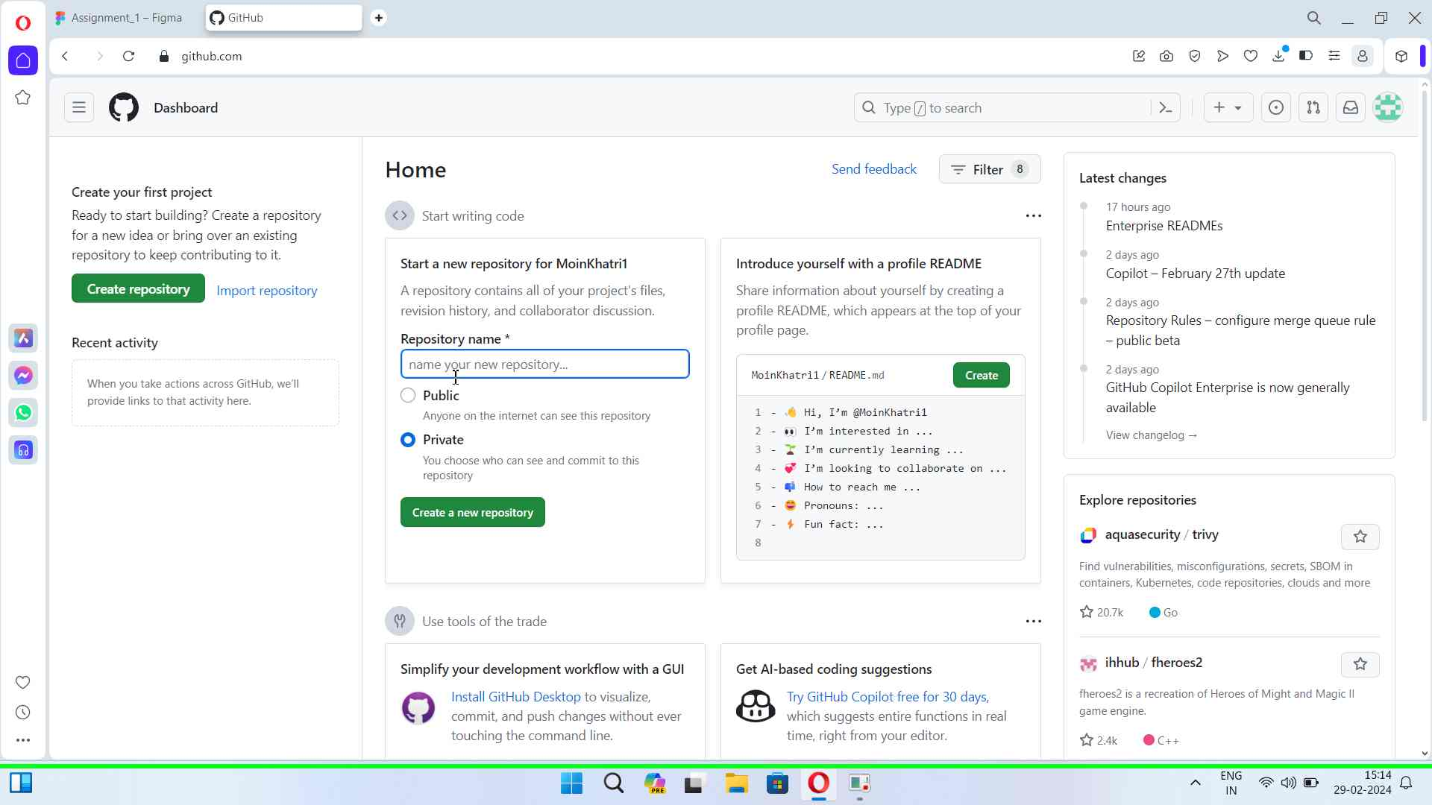Step 5 screenshot.

[Previous](#Step5" \o "Previous) [Next](#Step7" \o "Next)

**Step 6: (‎29-‎02-‎2024 15:14:42)** User left click on "Start a new repository (region)" in "GitHub - Opera"

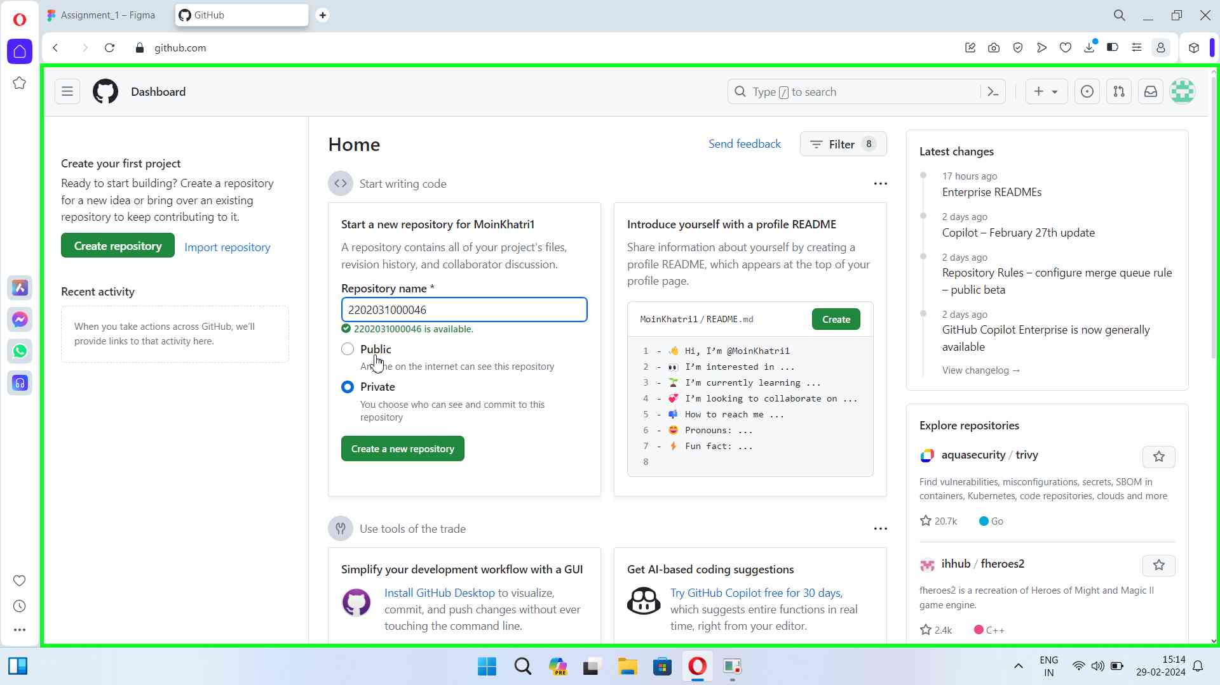Step 6 screenshot.

[Previous](#Step6" \o "Previous) [Next](#Step8" \o "Next)

**Step 7: (‎29-‎02-‎2024 15:14:45)** User left click on "Create a new repository (button)" in "GitHub - Opera"

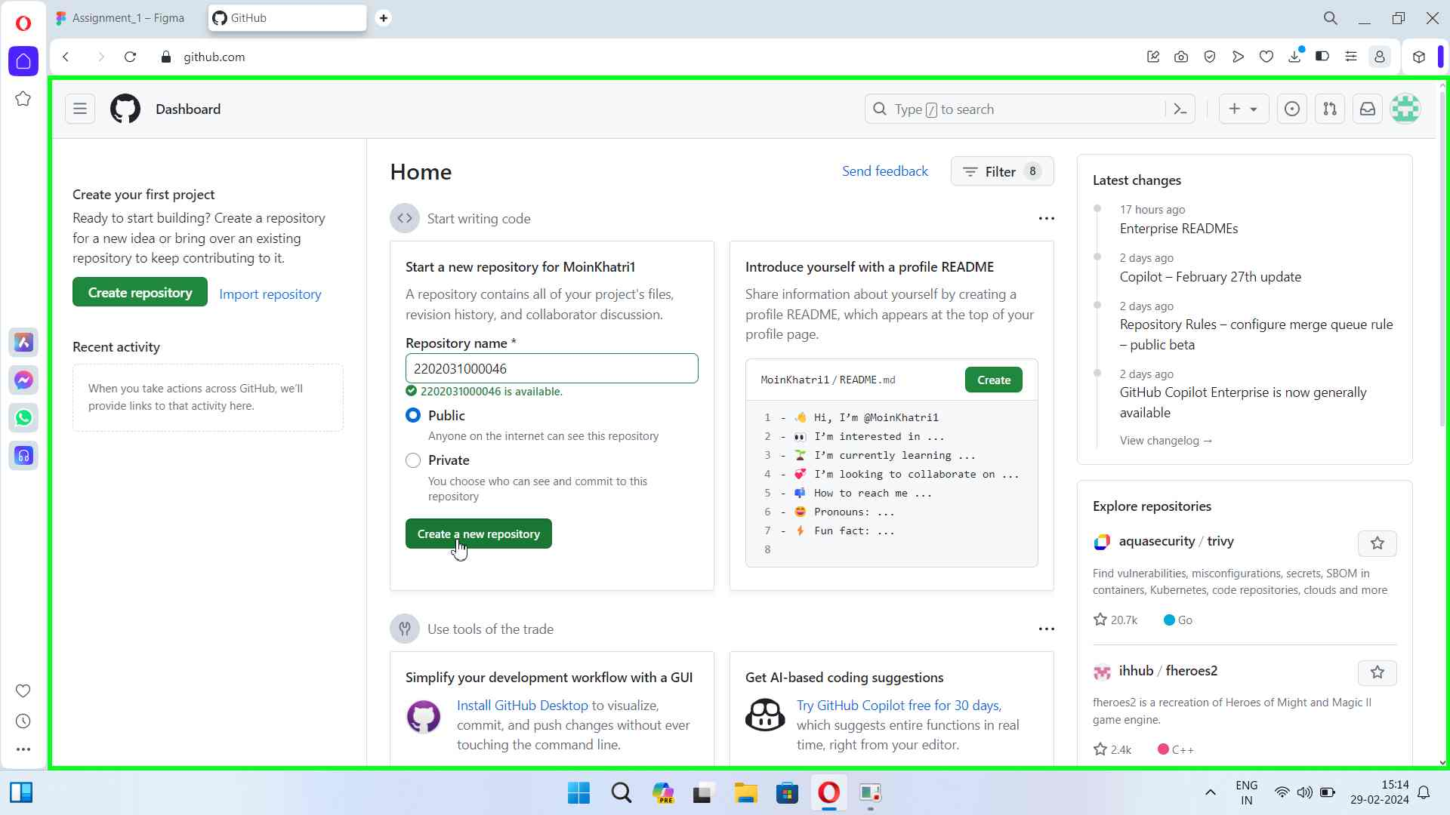Step 7 screenshot.

[Previous](#Step7" \o "Previous) [Next](#Step9" \o "Next)

**Step 8: (‎29-‎02-‎2024 15:14:50)** User left click on "MoinKhatri1/2202031000046 (document)" in "MoinKhatri1/2202031000046 - Opera"

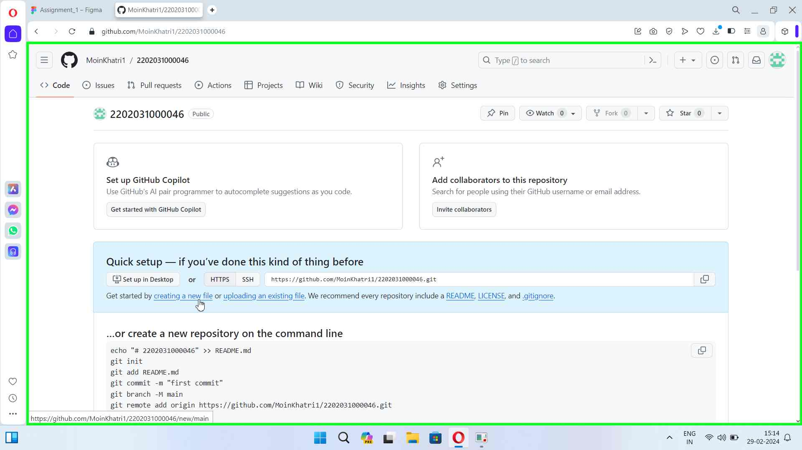Step 8 screenshot.

[Previous](#Step8" \o "Previous) [Next](#Step10" \o "Next)

**Step 9: (‎29-‎02-‎2024 15:14:55)** User left click in "New File at / · MoinKhatri1/2202031000046 - Opera"

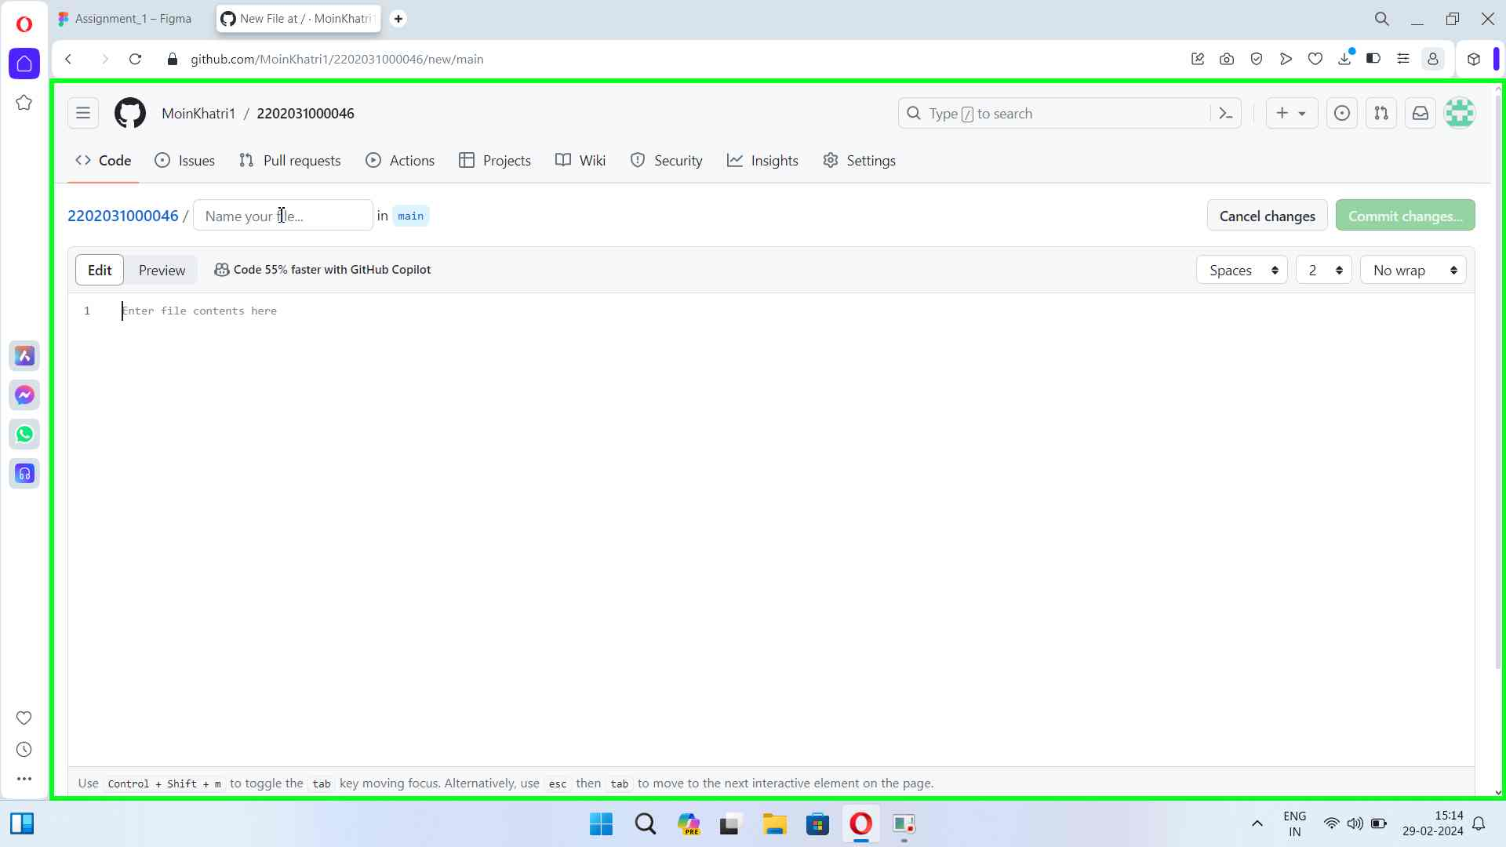Step 9 screenshot.

[Previous](#Step9" \o "Previous) [Next](#Step11" \o "Next)

**Step 10: (‎29-‎02-‎2024 15:14:56)** User keyboard input on "New File at / · MoinKhatri1/2202031000046 - Opera (pane)" in "New File at / · MoinKhatri1/2202031000046 - Opera" [... Backspace ... Backspace ...]

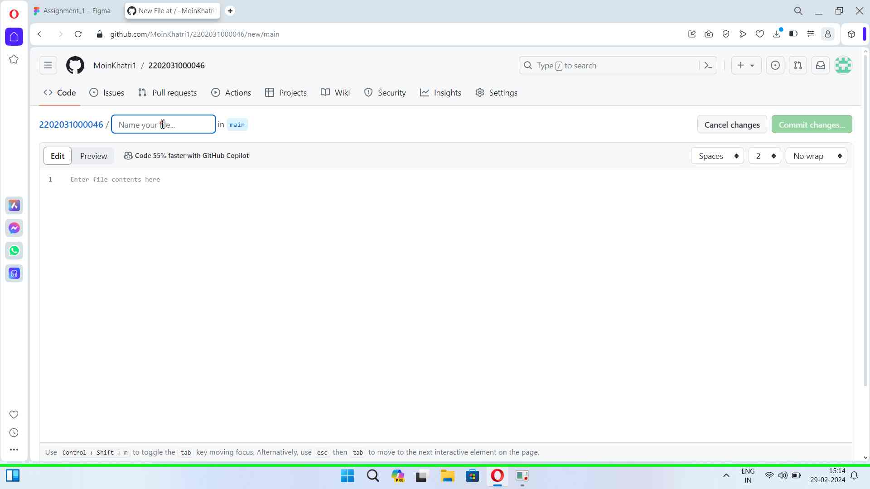Step 10 screenshot.

[Previous](#Step10" \o "Previous) [Next](#Step12" \o "Next)

**Step 11: (‎29-‎02-‎2024 15:15:16)** User left click in "New File at / · MoinKhatri1/2202031000046 - Opera"

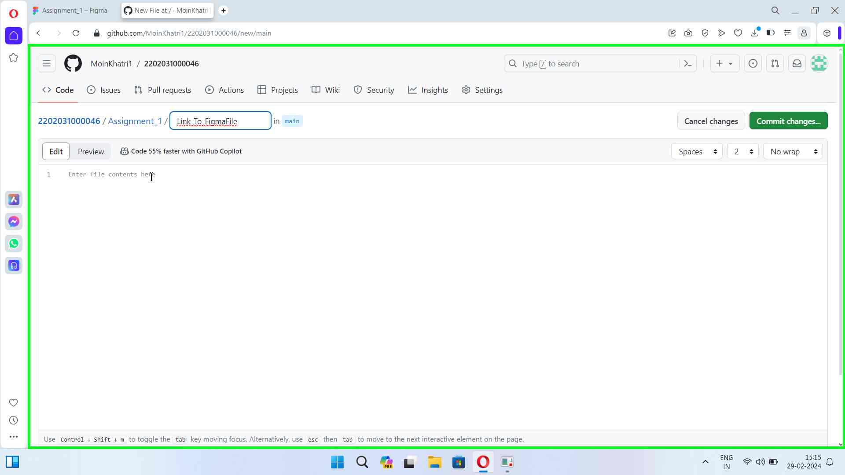Step 11 screenshot.

[Previous](#Step11" \o "Previous) [Next](#Step13" \o "Next)

**Step 12: (‎29-‎02-‎2024 15:15:17)** User keyboard input on "New File at / · MoinKhatri1/2202031000046 - Opera (pane)" in "New File at / · MoinKhatri1/2202031000046 - Opera" [... Ctrl-V]

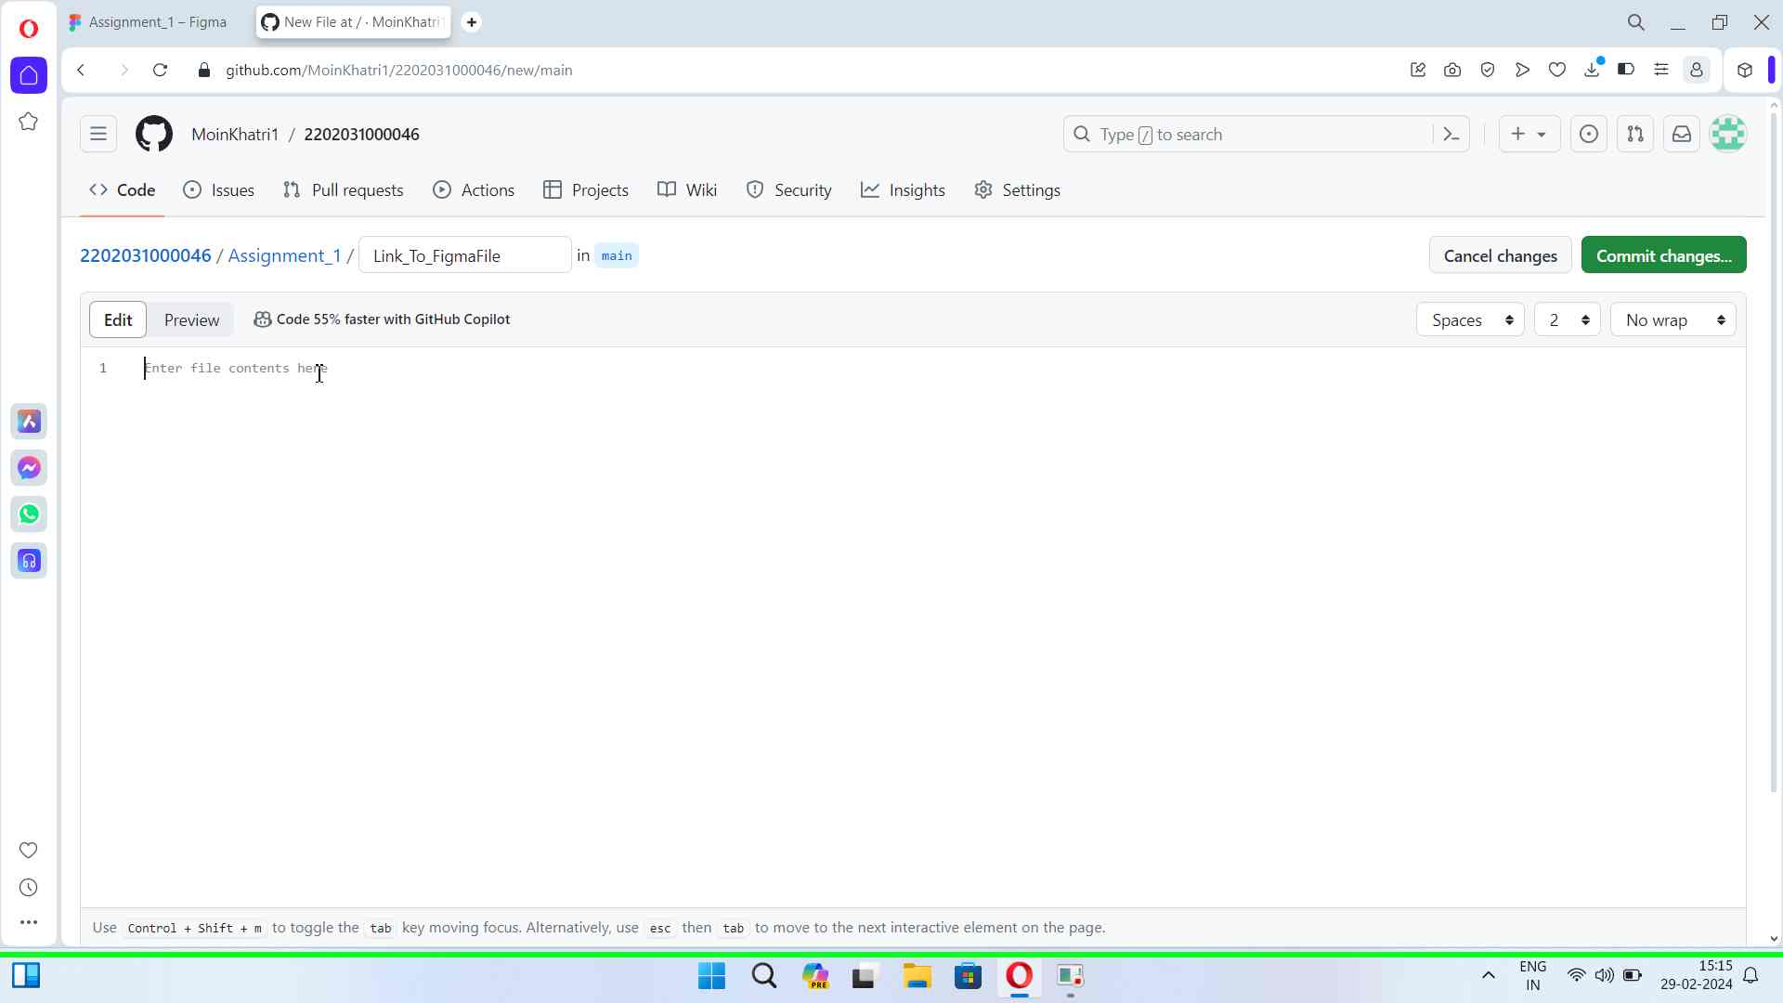Step 12 screenshot.

[Previous](#Step12" \o "Previous) [Next](#Step14" \o "Next)

**Step 13: (‎29-‎02-‎2024 15:15:20)** User left click in "New File at / · MoinKhatri1/2202031000046 - Opera"

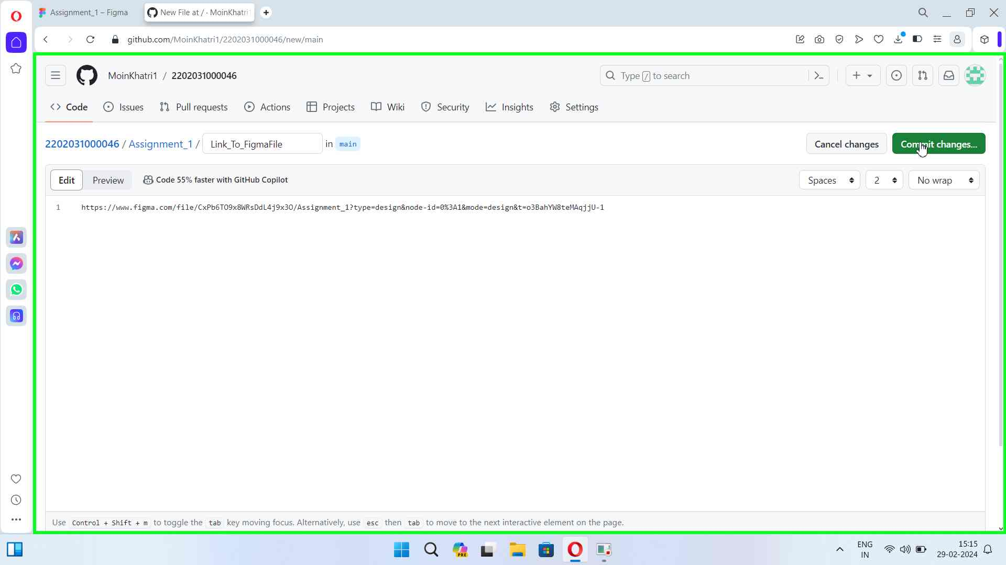Step 13 screenshot.

[Previous](#Step13" \o "Previous) [Next](#Step15" \o "Next)

**Step 14: (‎29-‎02-‎2024 15:15:26)** User left click in "New File at / · MoinKhatri1/2202031000046 - Opera"

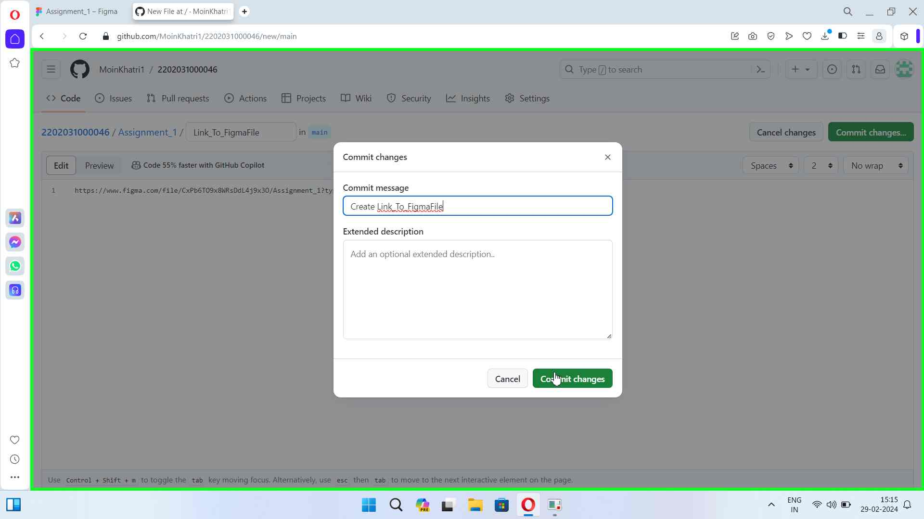Step 14 screenshot.

[Previous](#Step14" \o "Previous)

**Step 15: (‎29-‎02-‎2024 15:15:33)** User left click on "Steps Recorder - 1 running window (button)"

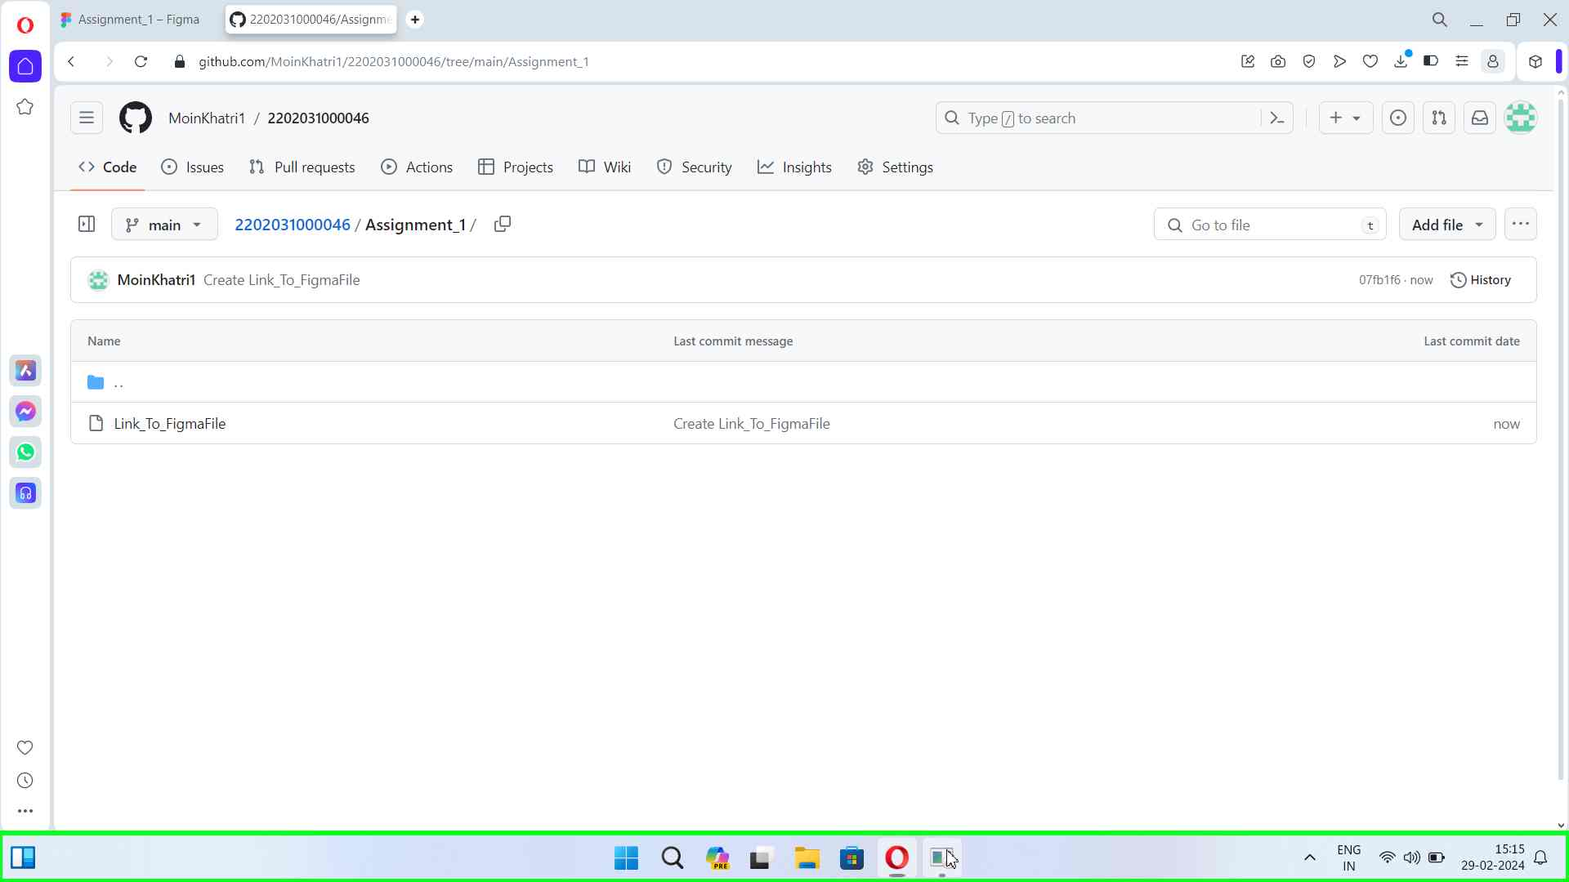Step 15 screenshot.

# Additional Details

The following section contains the additional details that were recorded.

These details help accurately identify the programs and UI you used in this recording.

This section may contain text that is internal to programs that only very advanced users or programmers may understand.

Please review these details to ensure that they do not contain any information that you would not like others to see.

Recording Session: 29-02-2024 15:14:17 - 15:15:38  
  
Recorded Steps: 15, Missed Steps: 0, Other Errors: 0  
  
Operating System: 22621.1.amd64fre.ni_release.220506-1250 10.0.0.0.2.100  
  
Step 1: User left click on "Opera Browser - 1 running window (button)"  
Program: Windows Explorer, 10.0.22621.1 (WinBuild.160101.0800), Microsoft Corporation, EXPLORER.EXE, EXPLORER.EXE  
UI Elements: Opera Browser - 1 running window, Taskbar.TaskListButtonAutomationPeer, Taskbar.TaskbarFrameAutomationPeer, Windows.UI.Input.InputSite.WindowClass, DesktopWindowXamlSource, Windows.UI.Composition.DesktopWindowContentBridge, Taskbar, Shell_TrayWnd  
  
Step 2: User keyboard input on "Speed Dial - Opera (pane)" in "Speed Dial - Opera" [... Enter]  
Program: Opera Internet Browser, 107.0.5045.36, Opera Software, OPERA.EXE --RAN-LAUNCHER --STARTED-FROM-SHORTCUT, OPERA.EXE  
UI Elements: Speed Dial - Opera, Chrome_WidgetWin_1  
  
Step 3: User left click on "github - Google Search (document)" in "github - Google Search - Opera"  
Program: Opera Internet Browser, 107.0.5045.36, Opera Software, OPERA.EXE --RAN-LAUNCHER --STARTED-FROM-SHORTCUT, OPERA.EXE  
UI Elements: github - Google Search, Chrome_RenderWidgetHostHWND, github - Google Search - Opera, Chrome_WidgetWin_1  
  
Step 4: User left click on "Repository name (edit)" in "GitHub - Opera"  
Program: Opera Internet Browser, 107.0.5045.36, Opera Software, OPERA.EXE --RAN-LAUNCHER --STARTED-FROM-SHORTCUT, OPERA.EXE  
UI Elements: Repository name, Start a new repository, GitHub, Chrome_RenderWidgetHostHWND, GitHub - Opera, Chrome_WidgetWin_1  
  
Step 5: User keyboard input on "GitHub - Opera (pane)" in "GitHub - Opera" [...]  
Program: Opera Internet Browser, 107.0.5045.36, Opera Software, OPERA.EXE --RAN-LAUNCHER --STARTED-FROM-SHORTCUT, OPERA.EXE  
UI Elements: GitHub - Opera, Chrome_WidgetWin_1  
  
Step 6: User left click on "Start a new repository (region)" in "GitHub - Opera"  
Program: Opera Internet Browser, 107.0.5045.36, Opera Software, OPERA.EXE --RAN-LAUNCHER --STARTED-FROM-SHORTCUT, OPERA.EXE  
UI Elements: Start a new repository, GitHub, Chrome_RenderWidgetHostHWND, GitHub - Opera, Chrome_WidgetWin_1  
  
Step 7: User left click on "Create a new repository (button)" in "GitHub - Opera"  
Program: Opera Internet Browser, 107.0.5045.36, Opera Software, OPERA.EXE --RAN-LAUNCHER --STARTED-FROM-SHORTCUT, OPERA.EXE  
UI Elements: Create a new repository, Start a new repository, GitHub, Chrome_RenderWidgetHostHWND, GitHub - Opera, Chrome_WidgetWin_1  
  
Step 8: User left click on "MoinKhatri1/2202031000046 (document)" in "MoinKhatri1/2202031000046 - Opera"  
Program: Opera Internet Browser, 107.0.5045.36, Opera Software, OPERA.EXE --RAN-LAUNCHER --STARTED-FROM-SHORTCUT, OPERA.EXE  
UI Elements: MoinKhatri1/2202031000046, Chrome_RenderWidgetHostHWND, MoinKhatri1/2202031000046 - Opera, Chrome_WidgetWin_1  
  
Step 9: User left click in "New File at / · MoinKhatri1/2202031000046 - Opera"  
Program: Opera Internet Browser, 107.0.5045.36, Opera Software, OPERA.EXE --RAN-LAUNCHER --STARTED-FROM-SHORTCUT, OPERA.EXE  
UI Elements:   
  
Step 10: User keyboard input on "New File at / · MoinKhatri1/2202031000046 - Opera (pane)" in "New File at / · MoinKhatri1/2202031000046 - Opera" [... Backspace ... Backspace ...]  
Program: Opera Internet Browser, 107.0.5045.36, Opera Software, OPERA.EXE --RAN-LAUNCHER --STARTED-FROM-SHORTCUT, OPERA.EXE  
UI Elements: New File at / · MoinKhatri1/2202031000046 - Opera, Chrome_WidgetWin_1  
  
Step 11: User left click in "New File at / · MoinKhatri1/2202031000046 - Opera"  
Program: Opera Internet Browser, 107.0.5045.36, Opera Software, OPERA.EXE --RAN-LAUNCHER --STARTED-FROM-SHORTCUT, OPERA.EXE  
UI Elements:   
  
Step 12: User keyboard input on "New File at / · MoinKhatri1/2202031000046 - Opera (pane)" in "New File at / · MoinKhatri1/2202031000046 - Opera" [... Ctrl-V]  
Program: Opera Internet Browser, 107.0.5045.36, Opera Software, OPERA.EXE --RAN-LAUNCHER --STARTED-FROM-SHORTCUT, OPERA.EXE  
UI Elements: New File at / · MoinKhatri1/2202031000046 - Opera, Chrome_WidgetWin_1  
  
Step 13: User left click in "New File at / · MoinKhatri1/2202031000046 - Opera"  
Program: Opera Internet Browser, 107.0.5045.36, Opera Software, OPERA.EXE --RAN-LAUNCHER --STARTED-FROM-SHORTCUT, OPERA.EXE  
UI Elements:   
  
Step 14: User left click in "New File at / · MoinKhatri1/2202031000046 - Opera"  
Program: Opera Internet Browser, 107.0.5045.36, Opera Software, OPERA.EXE --RAN-LAUNCHER --STARTED-FROM-SHORTCUT, OPERA.EXE  
UI Elements:   
  
Step 15: User left click on "Steps Recorder - 1 running window (button)"  
Program: Windows Explorer, 10.0.22621.1 (WinBuild.160101.0800), Microsoft Corporation, EXPLORER.EXE, EXPLORER.EXE  
UI Elements: Steps Recorder - 1 running window, Taskbar.TaskListButtonAutomationPeer, Taskbar.TaskbarFrameAutomationPeer, Windows.UI.Input.InputSite.WindowClass, DesktopWindowXamlSource, Windows.UI.Composition.DesktopWindowContentBridge, Taskbar, Shell_TrayWnd

[Return to top of page...](#ReportTop" \o "Return to top of page)